This website is produced to prepare second-year students from the Maastricht Hotel Management School (Hogere Hotelschool Maastricht) for a traineeship in Ireland. On the website you can find all the information you need about making a choice for a traineeship in Ireland or not.
You are probably standing for a total new experience in your life. You are maybe going to live somewhere abroad and you are going to work in a hotel where both the guests and the employees speak probably another native language. You can spend as a Trainee in various departments in a hotel in Ireland for 5 months. Something that is both exciting and valuable for the rest of your life. Not only will you improve your knowledge from the hospitality industry, but by all means also for your self-development. With this website we would like to give you an expression what you can aspect from a traineeship in Ireland, what the possibilities are, what the different is comparing to the Netherlands and what you need to know about the accommodation in Ireland. The objective of the traineeship in Ireland is to obtain a good overview of the hotel industry.

You will find the followings various aspects on the website:
- The Homepage with an introduction and a summary of what the second year students can
expect from the Ireland and the traineeship.
- The page “About Ireland”, where you can find information about Ireland itself. History from Ireland and between Ireland and Northern Ireland and the cultural aspect from:
•Hospitality
•The pub
•Religion
•Geography
- The page “Differences”, where you can find information about the cultural differences between the Netherlands and Ireland.
- The page “Opportunities traineeship”, where you can find information about the hotels and others opportunities for a traineeship in Ireland. Some examples of hotels in Ireland and what you can aspect from the hotels.
- The page “Accommodation”, where you can find information about the possibilities about the accommodation in Ireland.

Summary(You can find here all the information from the website in the summary under need):
About Ireland and the differences:
- Tourism is a significant contribution to the Ireland's economy
- The pub is maybe one of the most well known cultural aspect of Ireland. The pub or “public house” is part of Irish, British, Australian and New Zealand its culture.
- Ireland is divided in two different jurisdictions the Republic of Ireland and Northern Ireland. We only offer traineeships in the Republic of Ireland and not for the Northern Ireland.
- By the 90ties the industry of Ireland has involved into a modern industrial economy. In the history the Catholic Church was enormous powerful, but his influence reduced.
- The rooms are al lot more expensive then in Holland. Where you pay in Holland around 275 euro and in Amsterdam around 350 euro for a student room. You pay in Dublin for a small room easily € 400 euro. A room outside of Dublin is a lot cheaper.
- For a pint you pay in a bar easy 4 euro or more, it is cheaper to drink in a pub.
- In Ireland there are 9 universities, witch 4 of them are in Dublin.
Opportunities traineeship
- All the hotels we offer for your traineeship in a hotel in Ireland are part of a international chain. All the hotels are a 4 or 5 star hotel in Dublin, Cork or Athlone.
- You can find the chains in Ireland were most of the students will choice about on the page “Opportunities traineeship”.
- We can offer you a traineeship in 3 different departments in a hotel; F&B department, housekeeping department and the Front Office department.
  - In the Food & Beverage Department you will get the opportunity to learn how the F&B in a hotel from the early morning until the diner in the evening will go.
  - The housekeeping department is the ideal location to learn about precision and being critical to the college’s and yourself.
  - In the Front Office you will get the opportunity to learn how the Front Office in a hotel from the check out until the Check is working.
Accommodation
- The best and the quickest way to go to Ireland is to fly
- If you are an “European Economic Area” national, you do not need a work permit to coming to work in Ireland.
- If you are from the European Union you do not need a residence permit to coming to live in Ireland.
- You also need a PPS(Personal Public Service Number) to work in Ireland.

We hope that after you have read this webpage. You will have a clear vision about what you can aspect from a traineeship in Ireland. Also we hope that it will make your choice a little bit easier.

Please not that if you still may have questions about the traineeship you can contact your English teacher. If you have questions about the website, you can send an email to apchristianen@gmail.com.

If you want to download the complete information from the website in a lay out. Than please press the word button:

About Ireland
•Hospitality
The hospitality industry is a major worldwide industry. It is dynamic, competitive, fast growing and international. The wide ranging from the hospitality industry, covering everything from deluxe hotels, restaurants and design bars, to catering operations and nightclubs.
Tourism is a significant contribution to the Ireland's economy and it currently contributes for 6.2% of Gross National Product (GNP) and 5.7% of all exports. Thanks to tourism, Ireland can support three airlines, a large ferry company, dozens of quality golf courses and thousands of guesthouses, world class restaurants and hotels. The hospitality industry in Ireland is very important.
•The pub
The pub is maybe one of the most well known cultural aspects of Ireland. The pub or “public house” is part of Irish, British, Australian and New Zealand its culture. It’s not only a point where people come to getter to drink, but also a local point of the community. The different between a pub from bars and cafés is in the socially and culturally aspect. A pub is a social place based on the consumption of alcoholic beverages, and they offer a range of beers, wins, and spirits. Many of this pubs are owned by brewers and that is why often the beer is better valued than wine and spirits. The owner is also called the “pub landlord”, each pub has is locals and the guest that come by regularly are called regulars. The pub is important for the locals and the tourists and is something that will come by in your traineeship.
•Religion
Ireland is divided in two different jurisdictions the Republic of Ireland and Northern Ireland. We only offer traineeships in the Republic of Ireland and not for the Northern Ireland. That’s why we only give you information for the religion about the Republic of Ireland. In The Republic of Ireland the main religion is Roman Catholic Church with a percentage of 86 %. The most well known saint of Ireland is Saint Patrick. Every. Every year in Ireland on the 17th of March they celebrated Saint Patrick’s Day .
•History and Geography
Under need here we will tell you about the history from Ireland and between Ireland and Northern Ireland. Around 8000 BC(Before Christ) the first known hunter-gatherers arrived from Europe. When the missionaries Saint Patrick and the others arrived in Ireland around the year 600 the Celtic religion was completed in Ireland.
Ireland was invaded from the 8th century for more than a century by the Vikings. From the year 1169 different mercenaries from England went into Ireland and this marked the beginning of more than 700 years of British involvement in Ireland. In 1801 the Irish parliament was abolished and Ireland became an part of a new United Kingdom of Great Britain and Ireland in the Act of union. From 1880 Ireland strove to attain for a self government. In 1922 the larger part of Ireland seceded from the United Kingdom of Great Britain and Ireland. Six eastern counties in the northern of Ireland remained within the United Kingdom. This part of Ireland is also known as “Northern Ireland”. Soon after Ireland became seceded from the United kingdom the Irish Civil war followed. The history of Northern Ireland has since then dominated by the conflict between Nationalist(mainly Catholic) and Unionists(and protestant). This erupted in the late 60ties and it become better 30 years later. By the 90ties the industry of Ireland has involved into a modern industrial economy. In the history the Catholic Church was enormous powerful, but his influence reduced.

Differences
The traditions of Ireland often are from a 1000 year ago en are still normal in the modern day society.
The city Dublin is one of the city’s in Europe with the highest percentage of international students. It is very popular for French students, that want to improve their English. The differences between the Netherlands and Ireland for students are:
- The rooms are al lot more expensive than in the Netherlands. Where you pay in the Netherlands around 275 euro and in Amsterdam around 350 euro for a student room. You pay in Dublin for a small room easily € 400 euro. A room outside of Dublin is a lot cheaper.
- For a pint you pay in a bar easy 4 euro or more, it is cheaper to drink in a pub.
- In Ireland there are 9 universities, witch 4 of them are in Dublin.
- In the Netherlands the bars an pubs are later open then in Ireland.
The Irish music en the Irish dancing is very important in the modern day society.
The pub is a central place where everybody is coming together. In Ireland the pubs are also full in the weekdays, right after the people have finished their jobs.

An example of the Irish culture and music;

Opportunities traineeship
Hotels
All the hotels we offer for your traineeship in a hotel in Ireland are part of a international chain. All the hotels are a 4 or 5 star hotel in Dublin, Cork or Athlone. The chains in Ireland most of the students will choice about are:

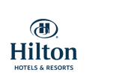

Hilton Dublin Airport

This hotel near the Dublin Airport is one of the best places to have your traineeship. A high number of students of the Maastricht Hotel Management School (Hoge Hotelschool Maastricht) already did here there traineeship. And all they said there were satisfied with their traineeship here. A busy hotel which have a gym, bar with comfy sofas, open fireplace and large windows, restaurant and fully
air-conditioned rooms. The hotel chain
“”Hiltons Hotels & Resorts” is a well know hotel chain.

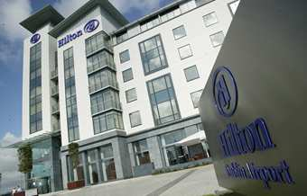

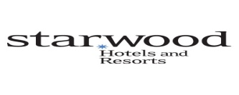

Sheraton Athlone Hotel

Thanks to its 12 storey glazed tower the “Sheraton Athlone Hotel” is a unique spa hotel in Ireland, it’s offers the guest all the comfort from a four star hotel. The hotel has a beautiful view over the River Shannon and the Sheraton Athlone Hotel a spa, a aquatics area, fitness center and lots of business facilities(includes eleven conference rooms).

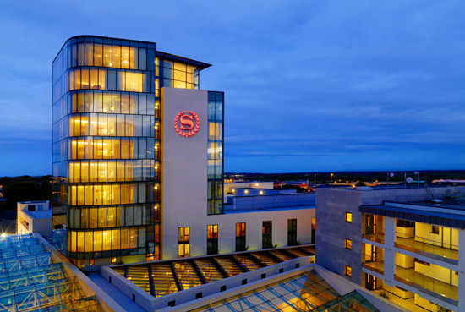

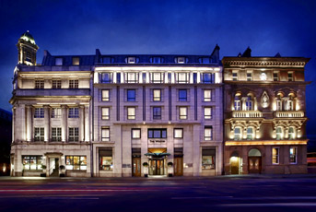

The Westin Dublin

The Westin Dublin is a luxury 5 star hotel in the heart of Dublin from the hotel chain “Starwood Hotels and Resorts”. This hotel offers there guest the following facilities; a Gym, Spa, 24-hours concierge service and a beauty and barber shop.

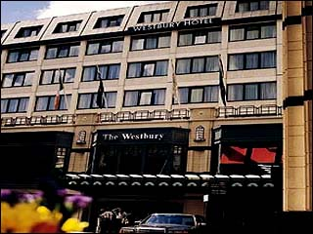
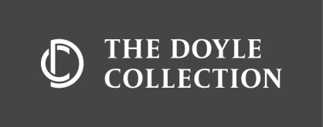

The Westbury Hotel Dublin

If you believe their own vision; this is one of the leading hotels in the world. In the last 2 years The Westbury Hotel is remodeled to a more stylish and luxurious hotel than before and with the vision to set a new standard in Dublin. This luxurious 5 star hotel in Dublin has 128 rooms, 2 restaurants and conference suites.

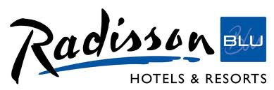

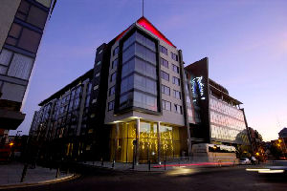

p.

Radisson Blu Royal Hotel Dublin

In the heart of Dublin you find this modern and luxurious Hotel. The hotel has 150 rooms and they are all supplied with a flat-panel LCD television, in-room coffee and tea provisions and a mini bar. The Hotel is ideal for business and leisure with the conference facilities.

Radisson Blu St. Helens’s Hotel Dublin

Just outside of the Dublin this Prestige’s 5 star hotel offers the guest spacious, luxury rooms with 26 inch LCD TV’s. With 151 rooms and only 8 miles from the airport and a 10 minute drive from Dublin’s city centre, the hotel has a ideal location.

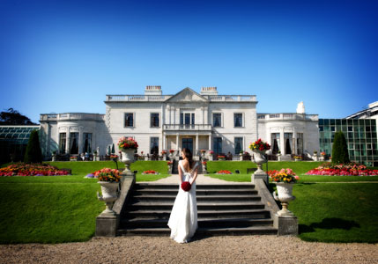

.

Opportunity type of traineeship
In your second year you are going to have a operational internship. After reading the information here above, you already have some examples from 6 different hotel. But what kind of internship do you prefer? One thing is important to keep in mind, this is that you are still learning and that you probably will have no experience in working in a hotel. We can offer you a traineeship in 3 different departments in a hotel; F&B department, housekeeping department and the Front Office Department.
- F&B Department
Here you will get the opportunity to learn how the F&B in a hotel from the early morning until the diner in the evening will go. You will help with all different parts of the hospitality that needs to be done, on a daily basis in a restaurant from a hotel. You will help with preparing the restaurant for the breakfast, lunch and dinner. Serving the guests and talk with the other employee’s in English.
- Housekeeping Department
Maybe you are now thinking;”What can a learn from a internship in the housekeeping?”. Well the housekeeping department is the ideal location to learn about precision and being critical to the college’s and yourself. You will teach yourself to be a manager or supervisor. Something that normally in your internships you only can do in your fourth year.
- Front Office Department
Here you will get the opportunity to learn how the Front Office Department in a hotel from the check out until the Check is works. You are going to check out en check in guest yourself. A good opportunity to train your language to a higher level. Also the guest will ask you for a lot of things that are not standard. You can think about: complaints, sightseeing, a extra pillow for the room and this is your responsibility to help the guest with his requests. You are also the first one a guest will see when he walks into the hotel.

Accommodation
The best and the quickest way to go to Ireland is to fly. Almost every Airlines in Europe is fly into Ireland. You can also get the boat from the UK or Europe.
A accommodation in Ireland is easy to find. The prizes are different from each region and especially in Dublin the prizes are high.
If you are an “European Economic Area” national, you do not need a work permit to coming to work in Ireland. The “European Economic Area” is the European Union (EU) + Norway, Iceland and Liechtenstein. Please, contact your teacher if you are not from the EEA and you have interest in doing a traineeship in Ireland.
If you are from the European Union you do not need a residence permit to coming to live in Ireland. Please, contact your teacher if you are not from the European Union and you have interest in doing a traineeship in Ireland.
You also need a PPS(Personal Public Service Number) to work in Ireland. You will need it for use in any transactions with public bodies. You need it for tax. You need it to work and you will need it to be paid by your employer.

You may visit the following websites;
- Link: http://www.studenthomes.eu/Dublin_student_rooms.php
- Link: http://www.thestudentroom.co.uk/wiki/Revision:A2_OCR_History_-_Britain_and_Ireland_1798-1921

Sources:
- http://www.mbahoteltourism.com/flash_intro.aspx?id=181&taal=en
- http://www.mastersportal.eu/
- http://www.icosirl.ie/eng/student_information/working_in_ireland
- http://www.citizensinformation.ie/en/travel_and_recreation/travel_to_ireland/student_visas.html
- www.google.com
- www.wikipedia.nl
- www.hotels.nl
- The followings books from the library;
  - “Great Britain and Ireland”
  - “Ierland ISBN: 90-18-00415-4”

