Reference images

Figuur 1: Inpassing stadspark in de Metropool New York.
www.21cmagazine.com

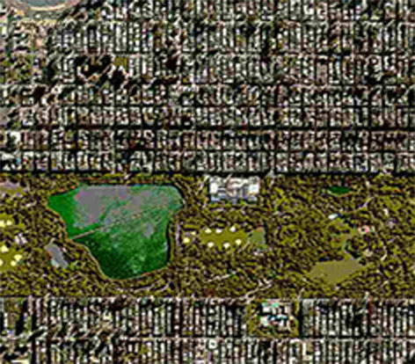
Keywords:

City park
Geomorphology
Metropool
Sub-soil
Recreation
Public space
Functions
Symbol
Ecological
Scale
Grid

Figuur 2: Het Nederlandse landschap als landschapspark.
Figuur 2: Het Nederlandse landschap als landschapspark.
www.gettyimages.com

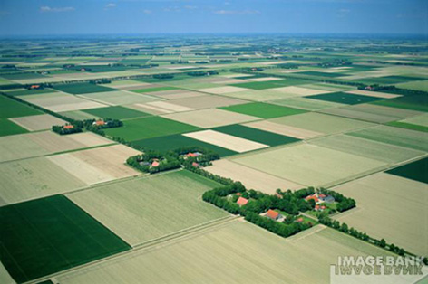
Keywords

Dutch landscape
Polder
Cultivation
Nature
Agriculture
Private
What kind of models, types, concepts and programmes could you derive

Figuur 1: Inpassing stadspark in de Metropool New York. |  | Figuur 2: Het nederlandse landschap als landschapspark.
City park enclosed in a geometric city plan | Models | Dutch rural landscape developed to a landscape park
Prominent situated city park in a metropolitan urban surrounding layered on a grid form | Types | The landscape gets a new meaning, from rural agriculture land to a Metropolitan Park System as leading spatial element of the Deltametropolis
Park designed before city evolved. After the city forming the park got it symbolism and worked as a metropolitan city park | Concepts | Landscape evolves to a different perspective of conservation and re-using the Dutch landscape to become a interesting green park system of different landscape to consolidate the Deltametropolis
Park, leisure, green, water storage, vegetation | Programmes | Green contours, park system, rural program (leisure, agriculture, scale enlargement)

Keywords

Dunes
Geomorphology
Landscape
Public space
Residence models
Water
Living conditions
Ecological structure
Bulb area
Metropolitan parksystem
Recreation

